Wireframe Model

Features Used
Bootstrap
- Mobile-First Design
  - Bootstrap has a primary focus on mobile-first design, with most elements and components being fluid, and adapting automatically to screen size. Hence, I have used Bootstrap’s features in order to ensure mobile compatibility for my site.
  - This can be shown in elements such as the top navigation bar, which automatically hides on smaller screens and turns into an expandable navbar. The grid system also automatically adjusts the number of items in each row and column dynamically, depending on screen size.
- Components
  - Bootstrap includes many components to speed up and simplify web development. I have used these features to my advantage. An example of this would be the Cards component, which I used in the index page.
  - Bootstrap was also used to implement my site’s navigation system – the navbar.

JavaScript
- Navbar in navbar.html file
  - JavaScript was used in order to load the navbar from navbar.html on each page, instead of copy & pasting the entire navbar.
  - This allows changes to be made in 1 location, instead of having to go through every single page.
- Bootstrap components that use JavaScript
  - I have used several Bootstrap components that use JavaScript, such as Carousels.
- Finding nearby Go-Kart Tracks
  - On the bottom of the TdY.html page, I have included a button to show a map containing nearby Go-Kart tracks.
  - This was done by first finding the user’s latitude and longitude, then reverse-geocoding the coordinates into a compound code of postcode and city using the Google Maps Reverse Geocoding API, then using the Google Map Places API in order to find nearby tracks.

Advanced HTML
- Geolocation
  - Geolocation was used in order to gather the user’s coordinates in the TdY.html page in order to find the nearest Go-Kart Tracks.

Evaluation of Implementation

- Initially, for index.html, I planned on the text of the hero to be in front of the image. However, I discovered viewability issues with the image I chose, so I moved the image under the text. This also resulted in other layout changes to the hero section.

Site Testing
- I uploaded my site to GitHub Pages (https://hochunwong.github.io/comp1021resit/) in order to easily test the site on all my devices, such as my desktop, laptop, and phone.
- During development, I used the Live Server VS Code extension to preview changes as I went.
- Occasionally, I would also use Firefox’s Responsive Design Mode to preview my site in different screen sizes.
- I have also submitted my site for accessibility testing using the accessibility tester
- From my testing, I have come to the conclusion that my site is very responsive across devices, and is suitable for all device types I have tested for.

Proof of Testing
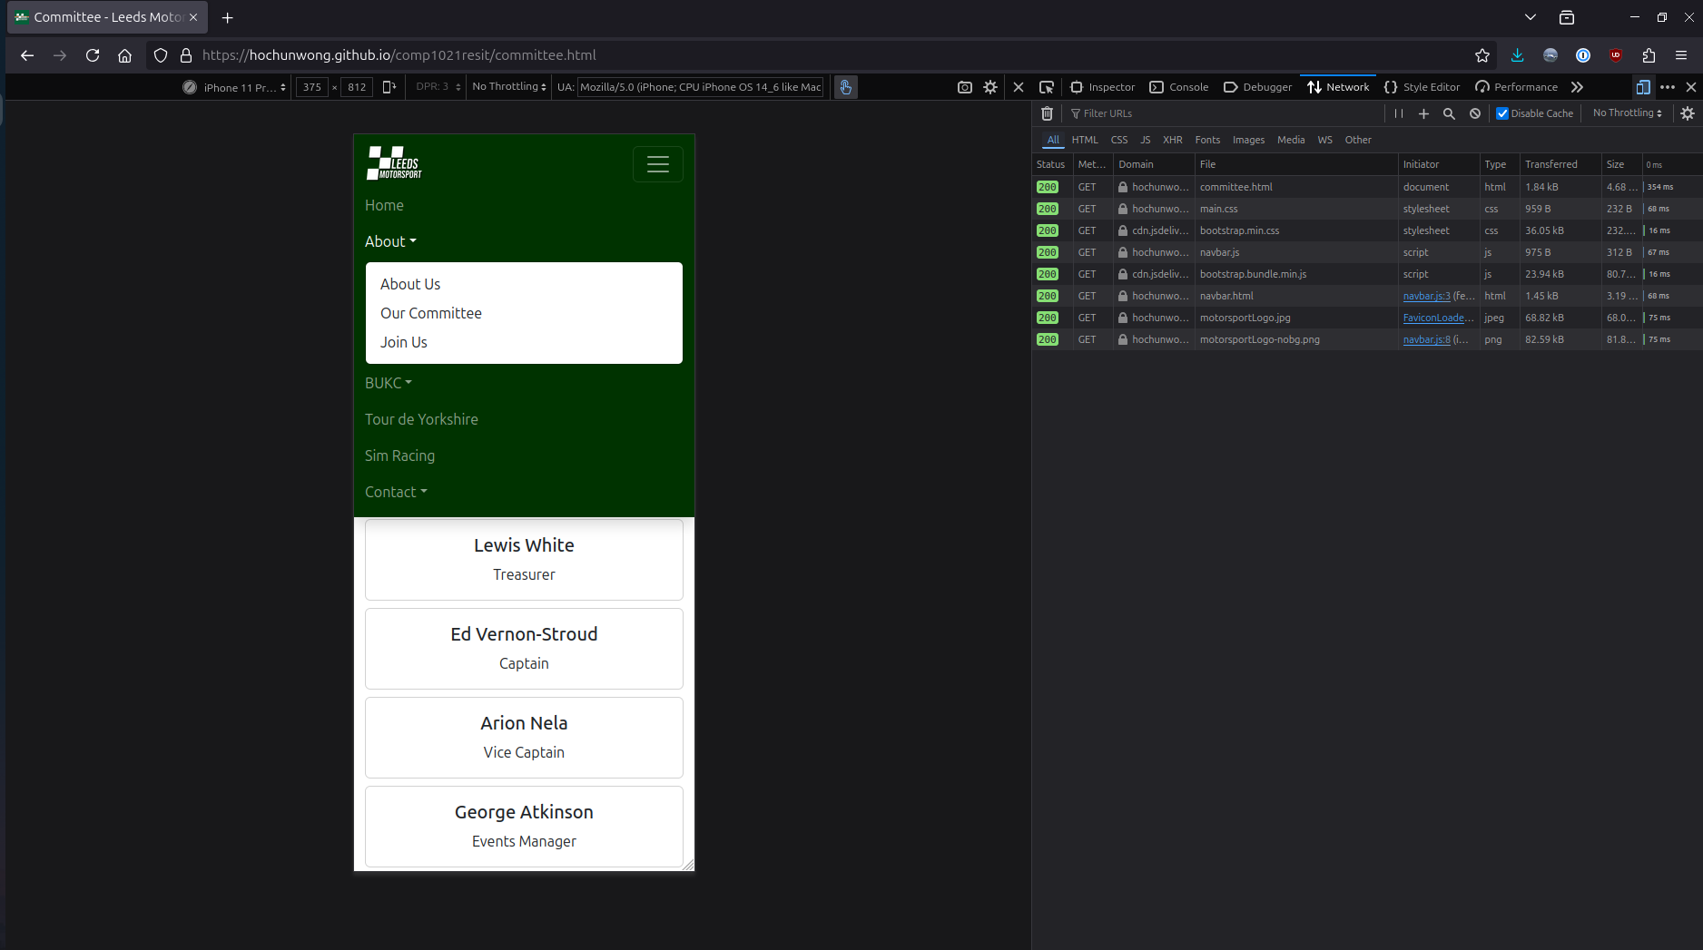
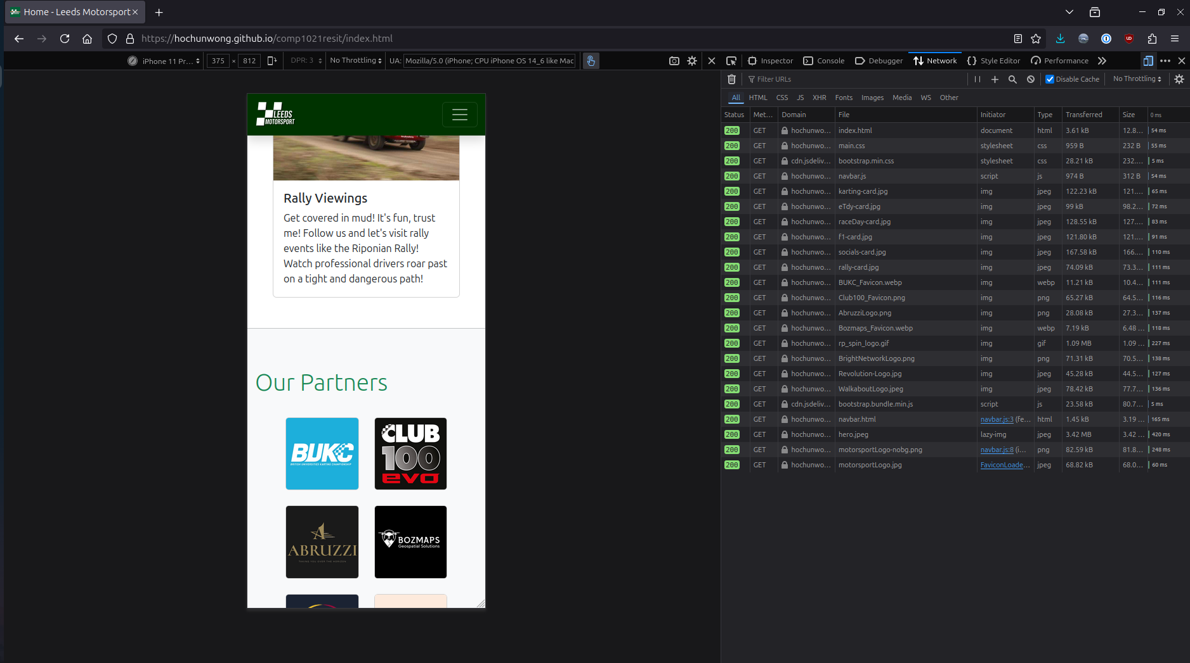
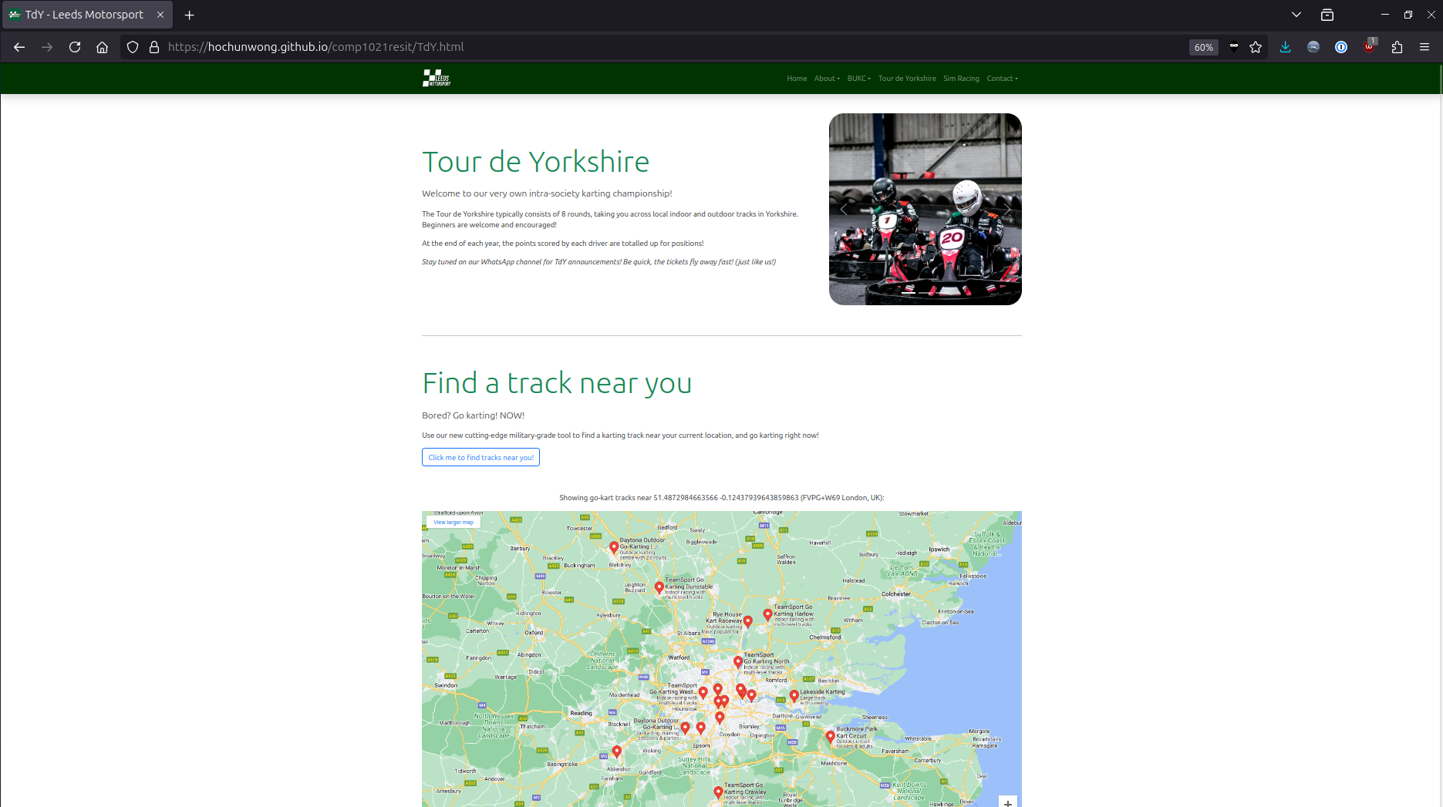
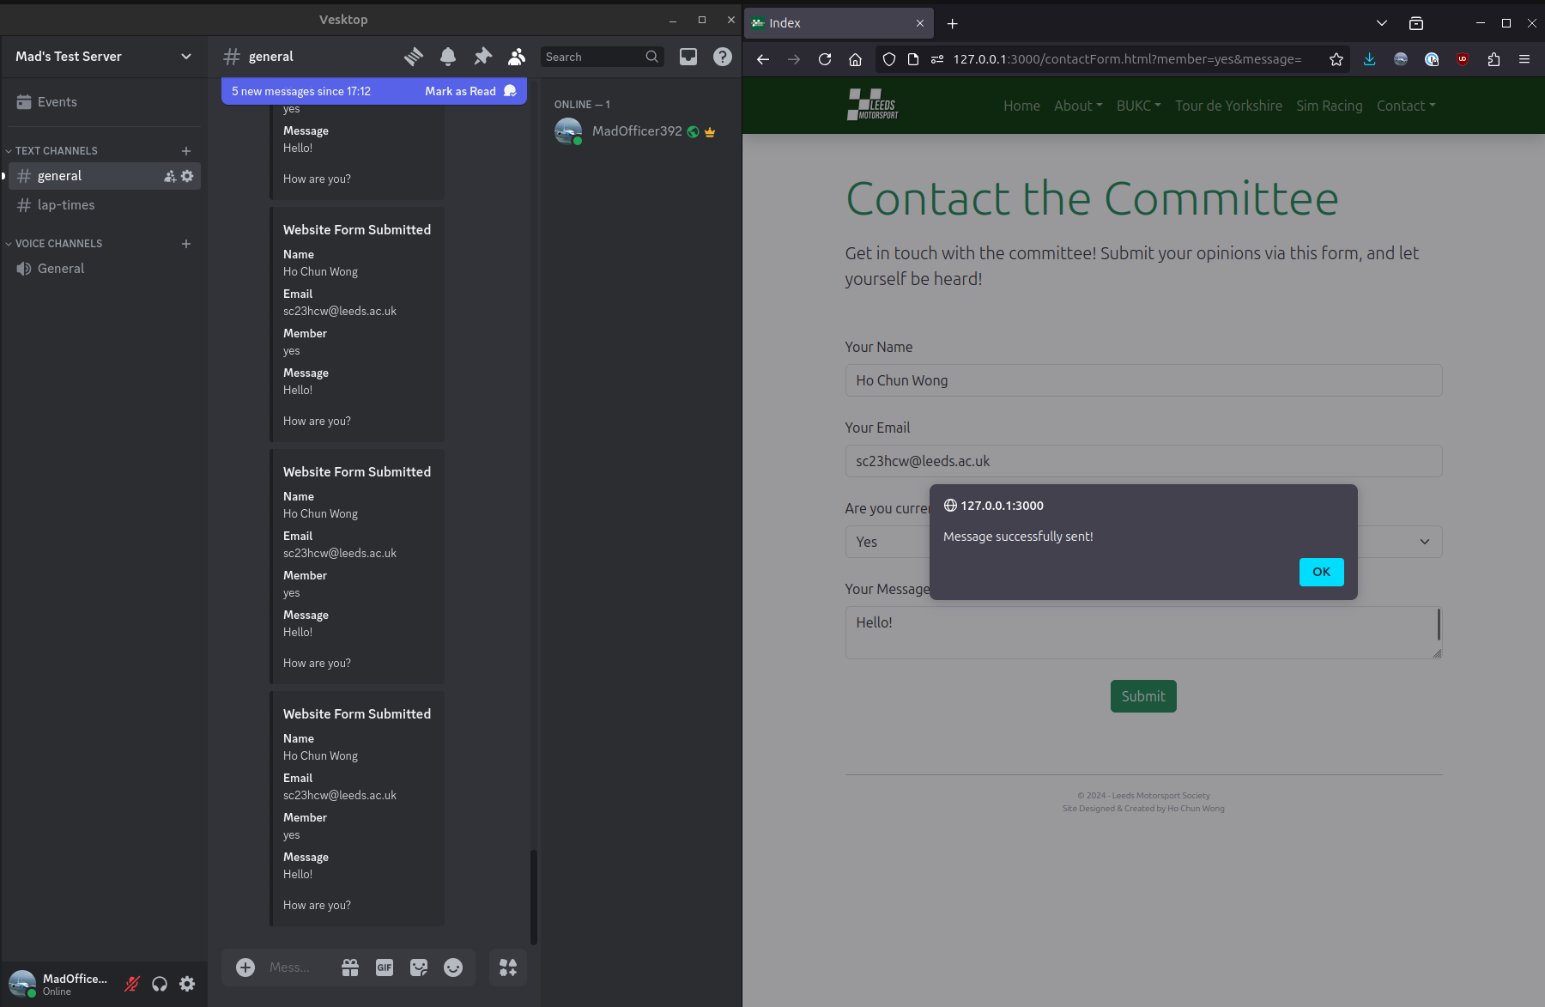
References

Asset | Source
/assets/motorsport-Logo.png/
/assets/motorsport-Logo.jpg/
/assets/hero.jpeg/
/assets/eTdy-card.jpg/
/assets/karting-card.jpg/
/assets/raceDay-card.jpg/
/assets/f1-card.jpg/
/assets/rally-card.jpg/
/assets/socials-card.jpg/

